Possibility of Starting Animal Production Market in Saudi Arabia
Student’s Name
Institutional Affiliation
Possibility of Starting Animal Production Market in Saudi Arabia
Animal production market in Saudi Arabia has attracted a lot of investors from all over the country and also outside the country. The government of Saudi Arabia has been heavily involved in the animal production industry by providing incentives to the traders and farmers with the necessary equipment. On the other hand, the developed countries have also appraised the practice of animal production since there lies a high possibility to gain vast profit from the market. This has made Saudi Arabia reduce its dependency on food import requirements up to 70 percent. Consequently, Saudi Arabia has been able to participate healthily in international trade since the country has something tangible to offer. For that reason, the paper will look at the challenges, chances and opportunities of entering into the animal production market in Saudi Arabia.
Challenges of Entering the Animal Production Market
There are several challenges facing the animal production market mostly when dealing with camels and goats in Saudi Arabia. According to Grindle et al. (2015), these challenges have inhibited smooth operation of the market an aspect that has scared some of the investors out of the country. Some of the challenges have been taken care of although others are yet to be solved. To have a clear picture of the situation of the animal production market in Saudi Arabia, it is wise to have a brief discussion of the challenges being faced by investors in Saudi Arabia. This will help to make well-informed decisions on whether an individual should engage in animal production market dealing with camels and goats in Saudi Arabia or not.
Risk of catastrophic animal diseases is one of the challenges facing the animal production market in Saudi Arabia. Traders in the country have been facing this challenge for a considerable period of time making the animal production market not to be attractive. In Saudi Arabia, there has been a high risk of infection and this ends up wiping out large herds of camels and goats (Ashmag, 2016). Although many of the farmers have appraised the use of biosecurity measures this still does not give the traders of camels and goats a good reason as to why they should have faith and hope in the market. Many of the traders in the animal production market have ended up quitting the market and opt to participate in other sectors of the economy as a way to earn a living. The challenge of catastrophic animal diseases needs to be combated with by both the government, farmers and traders in animal production market to welcome the aspect of success in the market of camels and goats.
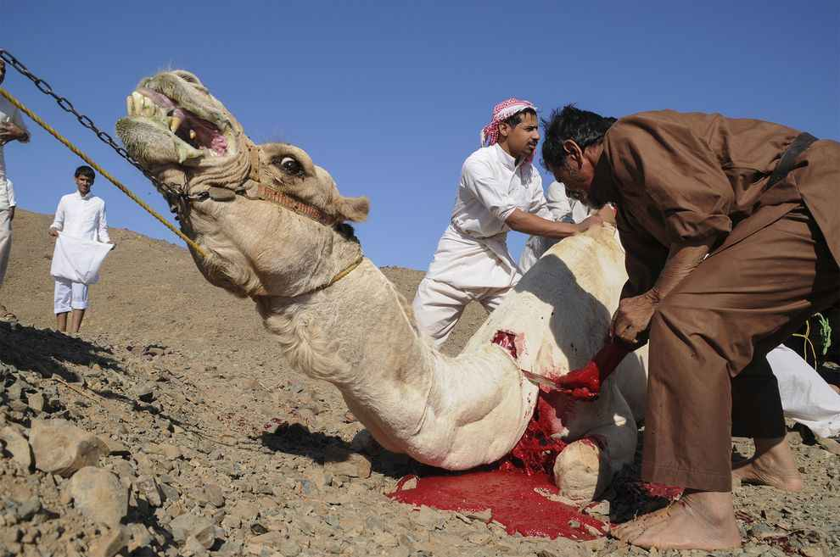
Figure 1: Sick camel (2017)
Handling waste and manure is also another challenge being faced in the animal production market in Saudi Arabia. According to Salih (2015), the environmental protection agency has put strict measures on how to handle manure runoff from farms especially that of camels and goats. Having such rules and regulations in place have reduced the number of farmers who practice animal production which in turns affect the animal production market. Most of the major concentrated animal feeding operations have to obtain a permit from the government to operate. Such permits have discouraged taking an active role in the animal production market in Saudi Arabia. Although farmers have raised their complaints on how the measures of handling waste and manure are being implemented, the response to the same has been minimal.
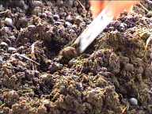
Figure 2: Goat manure (2017)
Food contamination is another challenge being faced in the animal production market in Saudi Arabia. In the past, there have been cases of contaminated meat specifically that for camels and goats which in turns leads to food-borne diseases. Since every issue to do with health is usually very sensitive, many residents of Saudi Arabia have reduced their meat consumption in fear of contaminating food-borne diseases (Ashmag, 2016). With such heightened consumer caution, it becomes a good reason to conclude that engaging in animal production market mostly in camels and goats in Saudi Arabia is not advisable at all. Although there has been government intervention to diagnose the existing camels and goats in the country, such efforts still do not make the residents gain the initial trust in the meat consumption.
Many of the consumers in the Saudi Arabia have started to worry about the use of antibiotics and growth hormones. This has made activists in the country to demonstrate and fight against the use of such antibiotics which have in turn affected the practice of livestock keeping in the country. As a result, farmers in the country have quitted in rearing camels and goats since they have been mandated to use some of the antibiotics and growth hormones of which they find not advisable to use (Grindle et al., 2015). This has, in turn, affected the supply of such animals in the animal production market thus lowering the output of the market. Use of antibiotics and growth hormones has made the practice of animal production market in Saudi Arabia mostly when dealing with camels and goats to be discouraging thus the chances of making a tangible profit from it becoming very low.
Competition from nonmeat products has also been intense in the country. The consumer demand for the nonmeat products in Saudi Arabia has been very high thus making the animal production market to record a decrease in income at the end of each financial year. According to Al-Mutairi et al. (2015), each financial year, economists have indicated huge losses being made in the animal production market mostly when dealing with camels and goats. As a result, many of the traders have opted to deal with nonmeat products which seem to have a high demand from the consumers. For example, the soya beans income in 2016 was approximated to more be than $600 from the information given by the soya beans sector in the country. Having the existing challenges of nonmeat products in Saudi Arabia make many of the investors to run away from the market thus making the animal production market mostly dealing with camels and goats to be discouraged. The availability of nonmeat products creates higher chances of traders to incur huge losses from the market thus giving enough reasons as to why indulging in the market in Saudi Arabia is not recommendable.
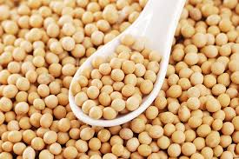
Figure 3: Soya beans (2017)
Chances and Opportunities for Entering the Animal Production Market
Although there are uncountable challenges faced when entering in the animal production market in Saudi Arabia, engaging in goat and camel production market in Saudi Arabia also has high possibilities to succeed due to the availability of ready market (Dickson, 2015). With the research that has been made in the past few years, Saudi Arabia has been exporting tonnes of camel and goat meat from Somalia. This has been facilitated by the booming oil prices hence making most of the citizens in the country to afford to buy meat and prefer it over other types of foods. With this in mind, it means that engaging in the animal production market in Saudi Arabia will be boosted by the high demand for the camel and goat products which is also predicted to increase in the future. In one year, Saudi Arabia is estimated to export over 3 million goats and camels for human consumption. This is a clear indication that animal production market has higher chances of succeeding.
The various religious festivals celebrated in Saudi Arabia offers more chances for the animal production market to succeed. For example, during the Eid al-Adha, the feast is usually attended by thousands of believers hence calling for large exports of goats and camels from the neighboring countries such as Somalia. According to Andrew & Finan (2013), keeping in mind that Saudi Arabia 99 percent of the inhabitants are Muslims, then this makes it clear that the number of occasions held at different times of the year is countless. For that reason, engaging in the animal production market in Saudi Arabia is recommendable since the religion of the country allows for the consumption of goat and camel meat and thus boost the market in one way or the other. Having several religious festivals held in the country gives the animal production market high chances of succeeding.
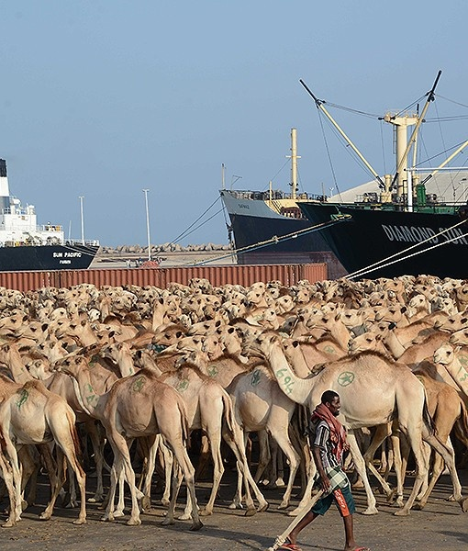
Figure 4: Camels being transported to Mecca (2017)
Lower taxes set by the government also improves the chances of the animal production market in Saudi Arabia to succeed. This has encouraged many investors to invest in Saudi Arabia. Information given out by reliable sources have revealed that traders in camels and goats have recorded high profits since what they, in turn, pay as revenue is very little (Bowen, 2014). For that reason, there is a higher possibility of succeeding in the animal production market in Saudi Arabia since the government has posed less tax. There lie many expectations that more and more investors will join the market of animal production in Saudi Arabia due to such favorable market conditions set by the state.
Availability of cheap labor is another opportunity that makes the animal production market in Saudi Arabia have a higher likelihood of success. Irrespective of where the trader comes from, once they land in Saudi Arabia there is cheap and high skilled labor that will help the animal production market to succeed. According to Abdel Rahman (2014), it has been discovered that most universities in Saudi Arabia offer courses in animal husbandry and marketing thus imparting the large portion of the youths with skills to run operations in the animal production market. This gives the animal production market to have higher chances of succeeding when compared to other types of markets in the country.
Political stability is another aspect that makes the animal production market have higher chances to succeed. The country now for several years has not had any conflict an aspect that has contributed to the growth of the economy as well. Peace is guaranteed in the country and this makes it obvious that the animal production market holds more chances of succeeding in Saudi Arabia because of the good environment for such a business with a ready market for camel as well as goat meat. Political stability is an important element in any country for the not only animal production market to succeed but also other types of markets in the economy (Dickson, 2015). This becomes a clear justification as to why any investor should be encouraged to invest in the animal production markets in Saudi Arabia.
Saudi Arabia has the highest percentage of gross domestic product in the world. A higher gross domestic product makes the citizens of the country have enough income to purchase the animal products (Abdel Rahman, 2014). No matter how high the prices of the products are, the citizens of the country can purchase the products they need since money is there. The source of the high gross domestic product has been said to result from the sale of oil that is plenty in the region. Thus, this becomes clear reason why the animal production market in Saudi Arabia is likely to succeed since the income to purchase the animal products is available. Therefore, investors from all over the world should not hesitate to invest in the animal production market in Saudi Arabia.
High government spending is another aspect that will make the animal production market in Saudi Arabia to succeed. The government invest heavily in the private sector and mostly favors the participants in the animal production market since the religion of the country encourages meat consumption during various religious festivals. According to Bowen (2014), having been funded by the government makes the traders incur fewer expenses in their operations making the market environment to be viable for the traders thus making many people in Saudi Arabia dealing with camels and goats to succeed in the market. On the other hand, the government provides incentives to the business people thus making the mode of operation to be a bit cheaper.
Developed infrastructure in Saudi Arabia also makes the animal production market to have higher chances of succeeding. Having such an opportunity in the region makes the transportation and communication in the market to be easy. The animal feeds are transported easily from one region to another (Bowen, 2014). On the other hand, in case of an outbreak, the medical services are availed faster through good communication which enables the traders to keep their animals healthy hence selling their animals at a high price in the market. Many scholars in Saudi Arabia have indicated that animal production market has even higher chances of succeeding due to the aspect of developed infrastructure in the country.
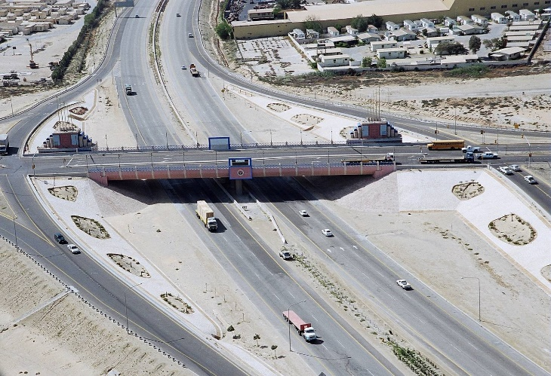

Figure 5: Infrastructure in Saudi Arabia (2017)
The booming service industry is another aspect making the animal production market to have high chances of succeeding. This helps to support the animal production market by offering financial support to the market. Once the farmers are equipped with financial resources, they have what it takes to succeed in the animal production market (Dickson, 2015). The booming service industry has made the economy to diversify thus increasing the possibilities of any new market venture to succeed. This makes Saudi Arabia be the most active trade partner in the Middle East and North Africa (MENA) region. Thus, no investor should hesitate to take an active role in the animal production market.
Favorable labor regulations in Saudi Arabia are also a contributing factor to the success of the animal production market. The government currently has formulated laws that favor most of the economic activities that take place in the country. According to Andrew & Finan (2013), most of the farmers and traders dealing with camel and goat production have been able to carry out their activities with ease since most of the regulations that have been laid favor their operations. For example, the Nitaqat law has regulated the number of foreigners from investing in the country thus enhancing the available ones to exploit their potential to the fullest by taking the advantage of the available market.
The above well discussed opportunities give a clear picture of the possibility of entering into the animal production market in Saudi Arabia. On the other hand, the challenges also exist thus making the indulgence in the animal production market to be a bit complicated. However, investors should weigh in between the opportunities, chances and challenges to decide whether to take an active role in the sector or not. Nevertheless, in our case, entering into the animal production market in Saudi Arabia is favorable considering the opportunities and high chances to succeed in the country.
In summation, it is evident that the animal production market in Saudi Arabia is faced with a number of challenges, chances and opportunities. Some of the challenges faced in the animal production market in Saudi Arabia include the risk of catastrophic animal disease, handling of waste and manual which has been highly emphasized by the environmental protection agency, food contamination, and use of antibiotics and growth hormones which has become a controversial issue to the farmers and the traders and competition from nonmeat products. However, there exist higher chances for the animal production market to succeed due to the various opportunities that are available in the country. One of the opportunities making the animal production market to have higher chances to succeed is due to the availability of ready market. The other opportunities making the animal production market to have higher chances to succeed are the several religious occasions in the country, lower taxes, cheap labor, political stability, higher gross domestic product, higher government spending, developed infrastructure, booming service industry and favorable labor regulations.

References
Abdel Rahman, A. R. J. E. N. (2014). Studies on Q fever in farm animals in Kingdom of Saudi Arabia (Doctoral dissertation, Sudan University of Science and Technology).
Al-Mutairi, S., Connerton, I., & Dingwall, R. (2015). Food safety organizations in Saudi Arabia–Organizational, historical and future analysis. Food control, 47, 478-486.
Andrew, G., & Finan, T. (2013). Navigating modernization: Bedouin pastoralism and climate information in the Kingdom of Saudi Arabia. MIT Electronic Journal of Middle East Studies, 4(Spring), 59-72.
Ashmag, F. A. M. (2016). Value chain of Sudan sheep exports to Saudi Arabia (Doctoral dissertation, University of Khartoum).
Bowen, W. H. (2014). The history of Saudi Arabia. ABC-CLIO.
Dickson, H. R. P. (2015). The Arab of the desert (RLE Saudi Arabia): A Glimpse into Badawin Life in Kuwait and Saudi Arabia (Vol. 1). Routledge.
Grindle, A. K., Siddiqi, A., & Anadon, L. D. (2015). Food security amidst water scarcity: Insights on sustainable food production from Saudi Arabia. Sustainable Production and Consumption, 2, 67-78.
Image for camels being transported to Mecca. (2017). Retrieved from https://www.google.com/url?sa=i&rct=j&q=&esrc=s&source=images&cd=&cad=rja&uact=8&ved=0ahUKEwjKlea-6KrXAhVBlRQKHfGAC50QjRwIBw&url=https:%2F%2Fwww.pinterest.com%2Fbaskoothalazoon%2Fcamels%2F&psig=AOvVaw3Gn2u2mWc0RNyZfj5Br2hk&ust=1510087486180497 on 6th November 2017.
Image for goat manure. (2017). Retrieved from https://www.google.com/url?sa=i&rct=j&q=&esrc=s&source=images&cd=&cad=rja&uact=8&ved=&url=http:%2F%2Fwww.fao.org%2Fag%2Faga%2Fagap%2Ffrg%2Frecycle%2Fearthwm%2Fmaworm.htm&psig=AOvVaw3FGwPMHa_Rp0rhEzI3I-Dp&ust=1510084452990071 on 6th November 2017.
Image for infrastructure in Saudi Arabia. (2017). Retrieved from https://www.google.com/url?sa=i&rct=j&q=&esrc=s&source=images&cd=&cad=rja&uact=8&ved=&url=http:%2F%2Fwww.constructionweekonline.com%2Farticle-18905-ksa-behind-uae-for-traffic-infrastructure-spend%2F&psig=AOvVaw1ufk-cOMMibcaZ4OffS4hA&ust=1510084845091568 on 6th November 2017.
Image for sick camel. (2017). Retrieved from https://www.google.com/url?sa=i&rct=j&q=&esrc=s&source=images&cd=&cad=rja&uact=8&ved=0ahUKEwjajZ_U5qrXAhXFWRQKHUYvCY8QjRwIBw&url=http:%2F%2Fwww.avianflutalk.com%2Fmers-patient-zero_topic31133.html&psig=AOvVaw0oYzWZfObWPOiQFX5zUIBU&ust=1510086920327685 on 6th November 2017.
Image for soya beans (2017). Retrieved from https://www.google.com/imgres?imgurl=http:%2F%2Fwww.snexportgroup.com%2Fwp-content%2Fgallery%2Fsoyabean%2Fsoya_beans.jpg&imgrefurl=http:%2F%2Fwww.snexportgroup.com%2Fsoya-beans%2F&docid=7Dci5bErWfEnCM&tbnid=lBWyvrIhnG4J5M:&vet=10ahUKEwiCyceQ3KrXAhWCWRQKHdGUCQwQMwg-KAIwAg..i&w=640&h=427&bih=662&biw=1366&q=image%20for%20soya%20beans&ved=0ahUKEwiCyceQ3KrXAhWCWRQKHdGUCQwQMwg-KAIwAg&iact=mrc&uact=8 on 6th November 2017.
Salih, M. I. (2015). The economics of Sudan chilled mutton exports to Saudi Arabia (Doctoral dissertation, UOFK).

